**Lab 7**

**1. After inspecting the time series:**

**a) What is the time range (start and end) of this time series?**

“month-year”

start: Jan-03

end: Dec-14

**b) How many values are there in this time series?**

144 value

**c) What is the time interval separating between each two consecutive values in the time series? (monthly, weekly, daily, yearly, etc)**

monthly

**2. What does the parameter frequency mean ? Why did we set it to 12?**

frequency: the number of observations per unit of time.

Because here our time unit is a year and the observations is monthly recorded.  
Since one year contains 12 months so, frequency is set to 12.

3. **After visualizing the time series:**

a) Add a neat plot of the generated time series

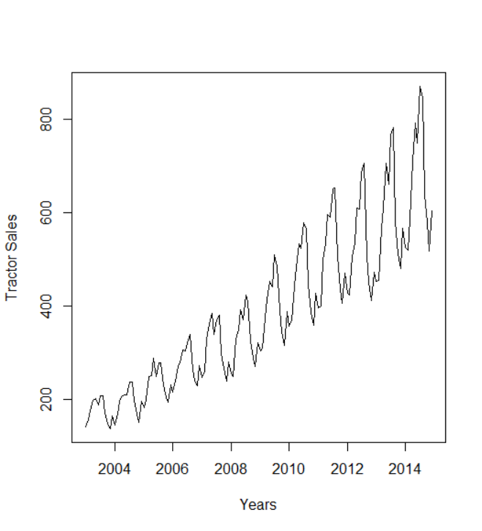

**b) Do you think there is a trend in the time series? If yes, then what is the**

**degree of the trend (i.e. is it linear, quadratic, .. etc)?**

Yes, linear “observed from the graph”

**c) Do you think there is a seasonality in the time series?**

Yes

**4. What does the function stl do? Add a neat plot of the plot generated**

Decompose a time series into seasonal, trend and irregular component.

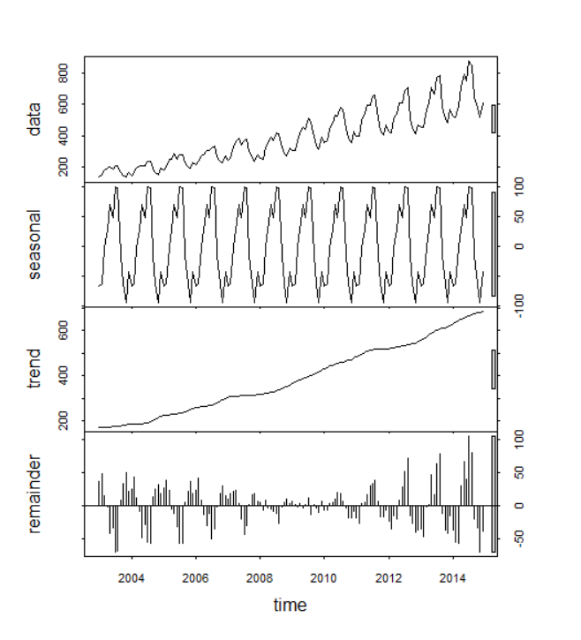

**5. Back to the original time series:**



**a) What are the two conditions imposed on the mean and the variance**

**of a time series to be stationary?**

To be stationary, the mean and the variance shouldn’t change over time

**b) Is this time series stationary? Mention the reasons behind your answer.**

No, there is trend and seasonality in this time series.

The mean increases over time.

The variance “the distance from mean” also increases over time.

There is also autocorrelation. ”seasonality”

6. **After differencing the time series:**

a) Add a neat plot of the time series after differencing.

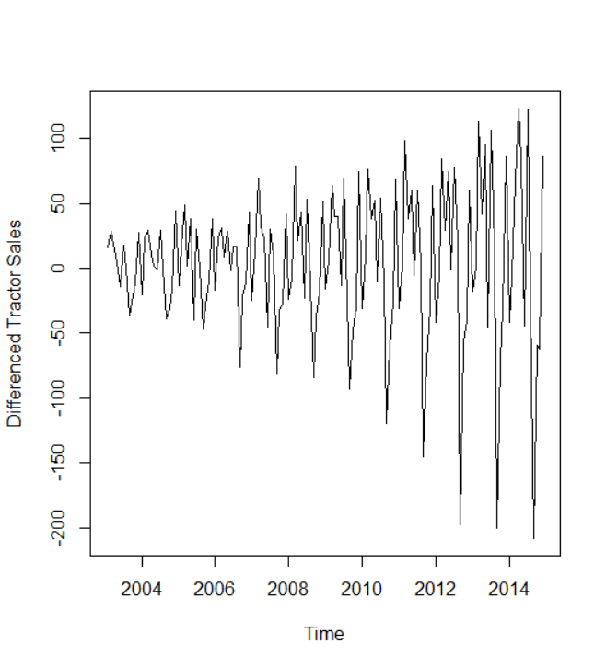

**b) Does the time series become stationary? Are the two conditions of the**

**mean and variance satisfied?**

No, the time series doesn’t become stationary

No, the variance still changes over time

**c) If no, which of the two conditions is still not satisfied for a stationary**

**time series?**

The variance still changes over time

**d) How does differencing help (not guarantee) to make a time series**

**stationary?**

It makes the mean constant.  
It’s like taking the derivative.  
Since the time series was linear, taking difference once will make the mean become constant.

7. **After applying logarithm to the time series, compare visually (5) and (7)**

**and you will know the answer to the following questions:**

a) Add a neat plot of the time series after applying logarithm.

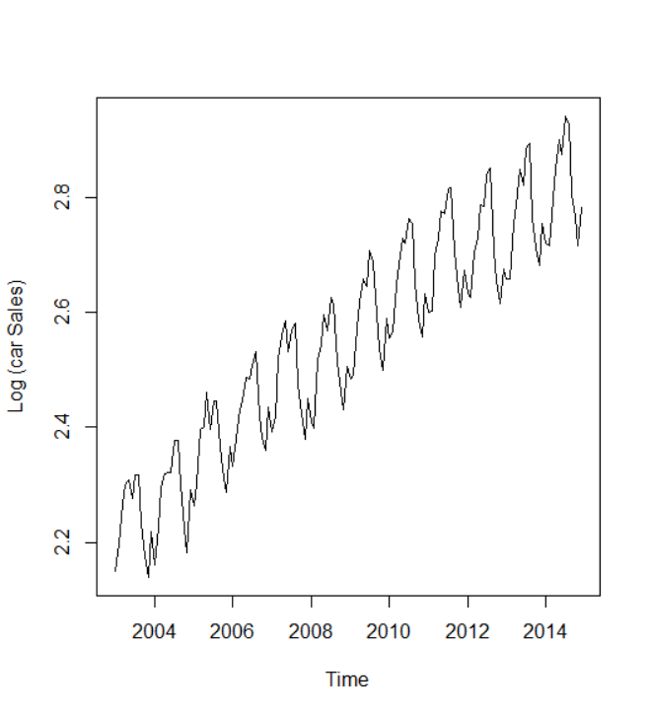

**b) Does the time series become stationary? Are the two conditions of the**

**mean and variance satisfied?**

No, it doesn’t.

No, the mean still changes over time.

**c) If no, which of the two conditions is still not satisfied for a stationary**

**time series?**

The mean still changes over time

**d) How does applying logarithm help (not guarantee) to make a time**

**series stationary? [This is a new piece of information never told in the**

**lecture or the tutorial].**

logarithms can help to stabilize the variance of a time series

8. **After applying both differencing and logarithm to the time series:**

**a) Does the time series become stationary? Are the two conditions of the**

**mean and variance satisfied?**

Yes, the time series becomes stationary

Yes, the two conditions are satisfied

**b) Add a neat plot of the final time series.**

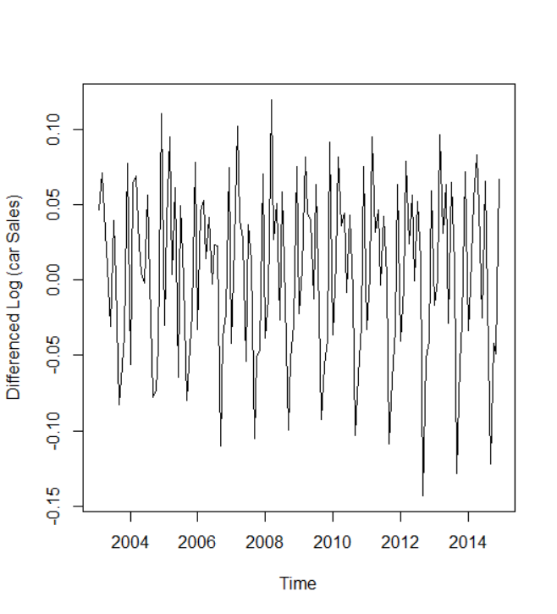

9. **After fitting an ARIMA Model with the logarithm of the time series:**

**a) What are the two requirements of ARIMA (or ARMA) models on the**

**time series data?**

Requirement:

1. Detrended time series
2. Seasonally-adjusted time series

(Stationary sequence).

But for ARIMA we can let it make the detrending part by differencing.

**b) Does the time series passed to the ARIMA model successfully hold the**

**two requirements? Why?**

No, There is still a trend in the time series “mean still changes over time”

and there is a seasonal effect in the time series so, we passed “seasnality = true” to the function-by default-.

**c) Inspect the summary of the model.**

ARIMA(0,1,1)(0,1,1)[12]

**The output of the ARIMA model is: (p,d,q) (P,D,Q)[S]**

What does the (p, d, q) mean?

p: number of autoregressive terms

d: number of differences

q: number of moving average terms

**What do you think the (P, D, Q)[S] relate to? (no details are needed).**

(P, D, Q) for the seasonal part of model.

[S] stands for number of periods in season. Here [12] is the number of months in year.

**d) Do you think that ARIMA model achieved the two requirements of (9-a)**

**internally? If yes, how did it happen briefly? You don’t need to give any**

**mathematical proofs or so. You just need to observe the ARIMA model**

**output (9-c) and you will get it.**

Yes, ARIMA did the differencing to detrend the time series by adding d=1 since the time series was linear, taking difference once will make the mean become constant

And it handled the seasonal effect through (P, D, Q)[S] by adding D = 1 as “seasonal = TRUE” is passed to the function.

**e) What do you think will be more suitable for the case of forecasting the**

**tractor sales, an autoregressive (AR) model or a moving average (MA)**

**model? Why**?

MA, the time series shows short term dependencies.

**10. After changing trace = True:**

**a) How is the best model selected? What is the information criterion used**

**in selecting the best model? [Mention only the name] [Check the help]**

ARIMA(0,1,1)(0,1,1)[12] : -702.6033

AIC=-702.79 AICc=-702.6 BIC=-694.17

The model is selected using Information Criteria AICc

**b) What other information criteria are there that can be used as well?**

**[Mention only the names][Check the help]**

AIC and BIC

**c) Do we seek to get the minimum value or the maximum value of this criterion?**

minimum

**11. What is the meaning of n.head = 36?**

The number of steps ahead for which prediction is required = 36 months

= 3 upcoming years

**12. After forecasting and plotting the future values**

**a) According to your observation, does this forecast work well?**

Yes, it follows the same trend and season as previous years

**b) Add a neat plot of the generated time series.**

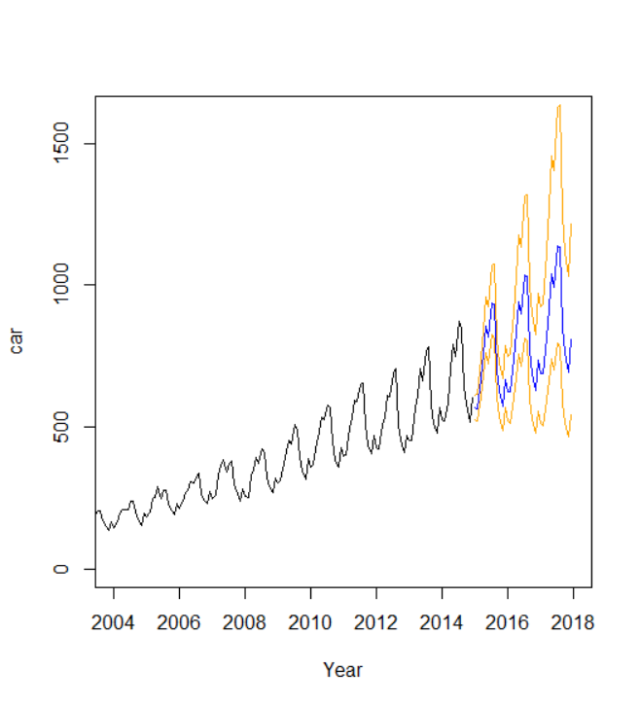

**13. After using TSPred library:**

**a) Does this library generate a similar plot to (12)? Why?**

No, because we took the log before passing the data to the ARIMA model  
The generated graph is variance constant not like the actual data.

**b) Add a neat plot of the generated time series.**

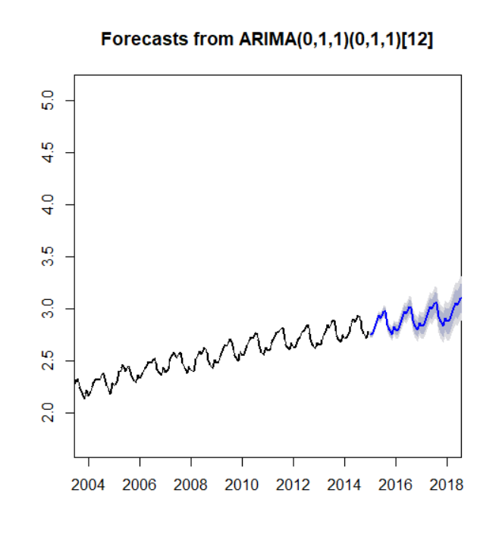

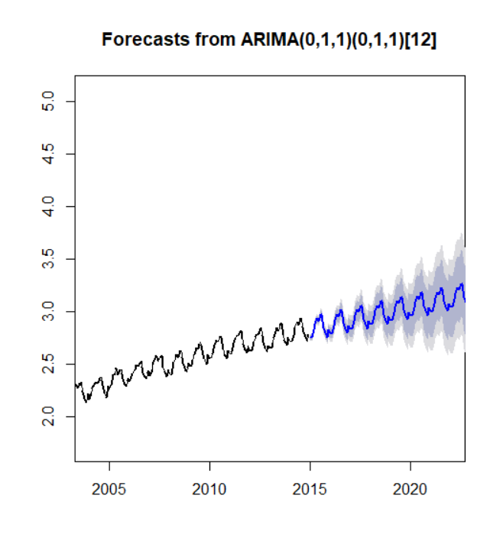

**14. What happened when we tried to forecast the tractor sales for an extended or longer time range? What do you notice?**

The probability of error increases as we extend the time range.